Multiple choice section

|  |  |  |  |  |  |  |  |  |  |  |
| --- | --- | --- | --- | --- | --- | --- | --- | --- | --- | --- |
| Question | 1 | 2 | 3 | 4 | 5 | 6 | 7 | 8 | 9 | 10 |
| Answer | C | A | B | A | B | A | A | C | B | B |

Question 1 [1.1]

C

12 + 3x = 18

12 + 3x – 12 = 18 – 12

3x = 6

x = 2

Question 2 [1.1]

A

7(a – 2) = 2(2a – 1)

7a – 14 = 4a – 2

3a = 12

a = 4

Question 3 [1.2]

B

m = 

= 

= -

Question 4 [1.2]

A

5x + y = 7

y = -5x + 7

Gradient = -5

Question 5 [1.2]

B

Lines parallel to the x-axis (horizontal lines) have a gradient of zero.

Question 6 [1.3]

A

y = mx + b

y = -2x + 3

Question 7 [1.4]

A

The line with equation y = 5x + 2 has the gradient of 5.

The other line with a gradient of 5 is y = 5x – 2.

These lines are parallel.

Question 8 [1.5]

C



Question 9 [1.5]

B

 < 2

4 – 6x < 18

-6x < 14

x > -2.3333...

So x = -2.7 is not a solution.

Question 10 [1.6]

B

Substitute y = 3x into y + x = 20:

3x + x = 20

4x = 20

x = 5

Substitute x = 5 into y = 3x:

y = 3 × 5 = 15

x = 5, y = 15

Multiple-choice total marks: 10

Short answer section

Question 11 10 marks

(a) A *linear relationship* exists between two variables when the graph of the relationship is a straight line.

(b) A linear relationship is described by a *linear equation*.

(c) Linear equations can be solved by applying *inverse operations* to both sides of the equation.

(d) The general equation of a straight line is y = mx + b where m is the gradient of the line and b is the *y-intercept* of the line.

(e) The *gradient* of a line is a measure of its steepness, which can be evaluated by evaluating the fraction *rise over run*.

(f) Lines that are *parallel* have the same gradients.

(g) Lines that are *perpendicular* meet each other at an angle of 90°.

(h) A linear equation has *one* solution and a linear *inequality* has a range of solutions according to the inequality.

Question 12 4 marks [1.3, 1.4]

(a) Lines that are parallel to the line y = 2x have a gradient of 2. The graphs of the lines need to have this gradient and an intercept on the y-axis consistent with each equation.

(b) Lines that are perpendicular to the line have a gradient of -. Graphs of the lines should have this gradient and a y-intercept consistent with each equation

Question 13 3 marks [1.1]

  
7x – 2 = 40

7x = 42

x = 6

Question 14 4 marks [1.1]

3(3x + 2) = 2(2x – 2)

9x + 6 = 4x – 4

9x = 4x – 4 – 6

9x = 4x – 10

9x – 4x = 10

5x = -10

x = -2

Question 15 2 marks [1.2]



Question 16 2 marks [1.2]

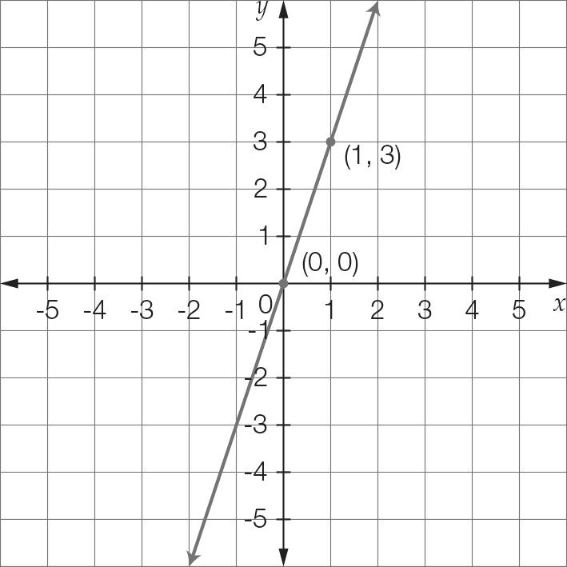

Using the points of (0, 0) and (1, 3)

Gradient = 

Question 17 2 marks [1.3]

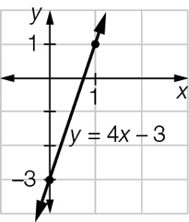

Question 18 4 marks [1.4]

(a) The equation y – 3x = 5 can be expressed as y = 3x + 5. As the lines y = 3x + 5 and y = 3x + 2 have the same gradients, they are parallel.

(b) The gradient of the line y = x – 3 is 1, and the equation y = -x – 2 has a gradient of -1.  
The product of their gradients is -1 (as 1 × -1 = -1), so the lines are perpendicular.

Question 19 4 marks [1.5]

(a) 3x ≥ 15  
x ≥ 5

(b) 6x – 2 > 10  
6x > 12  
x > 2

Question 20 4 marks [1.5]

(a) 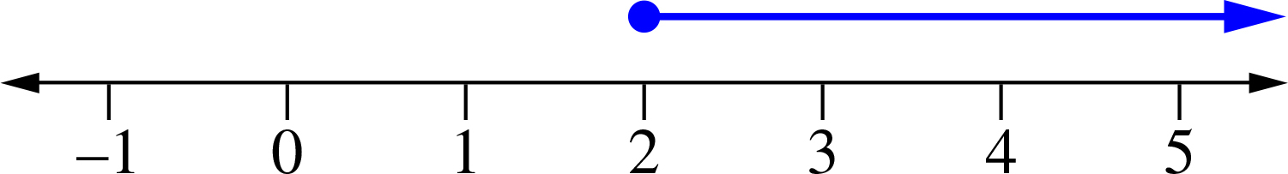

(b) 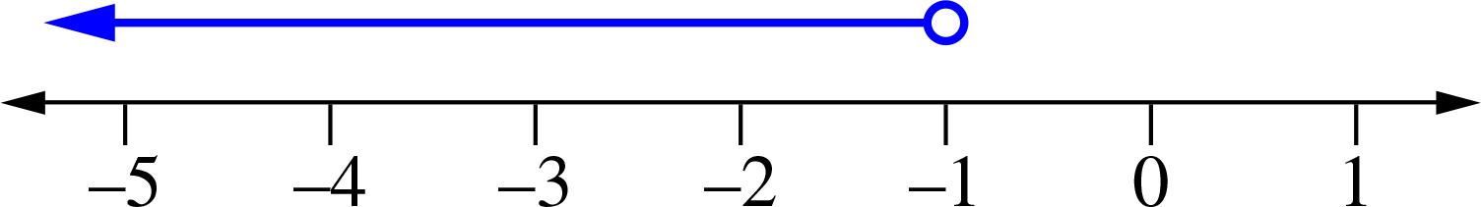

Question 21 4 marks [1.6]

Substitute y = x – 2 into the second equation.

2x + y = 13

2x + (x – 2) = 13

2x + x – 2 = 13

3x – 2 = 13

3x = 15

x = 5

Now find the value of y.

y = x – 2

y = 5 – 2

y = 3

Question 22 4 marks [1.6]

x + 2y = 7

4x – 2y = -2

5x = 5 [1] + [2]

x = 1

Now substitute the found value of x to find y.

x + 2y = 7

1 + 2y = 7

2y = 6

y = 3

x = 1 and y = 3

Short answer total:_________/47

Extended answer section

Question 23 3 marks [1.1]

2x – 1 + 2(x + 5) = 25

2x – 1 + 2x + 10 = 25

4x + 9 = 25

4x = 16

x = 4

x + 5 = 9

2x – 1 = 7

The dimensions are: two sides of 9 cm and one side of 7 cm.

Question 24 4 marks [1.5]



Then B = 7 – 2 = 5.

Each book costs $5 and each pen costs $2.

Question 25 4 marks [1.6]

(a)  where b is the number of buns.

(b) 20b ≤ 200

20b ≤ 200

b ≤  = 10

The baker can make up to 10 more buns.

Question 26 10 marks [1.2, 1.3, 1.4]

(a), (b) (i), (c) (i) 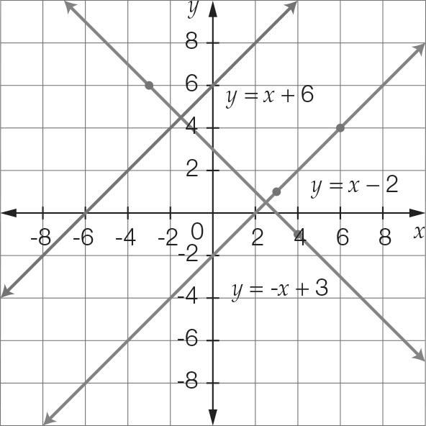

(b) (i) Equation of the line AB is y = x – 2.

(ii) The gradient of both lines is 1, so the lines are parallel.

(c) (i) Equation of the line CD is y = -x + 3.

(ii) The product of the gradients of the lines is -1, so they are perpendicular.

Extended answer total:_______/21

TOTAL test results: ______ / 78